

H.E.A.T. Study

Heat and Exercise in Aging as Therapy
Research participants are needed to determine whether heat pad therapy can improve muscle health, physical function, blood sugar control, and response to exercise in older adults with prediabetes.

Who are we looking for?
Men and women ≥ 60 years old with prediabetes (known or suspected)
who do not regularly exercise.
Study Timeline:
The study involves 2 phases that last 12 weeks each. Before the start and end of each phase, multiple testings will be performed, including:
- Blood (~6 tbsp each) and muscle (~200 mg) samples
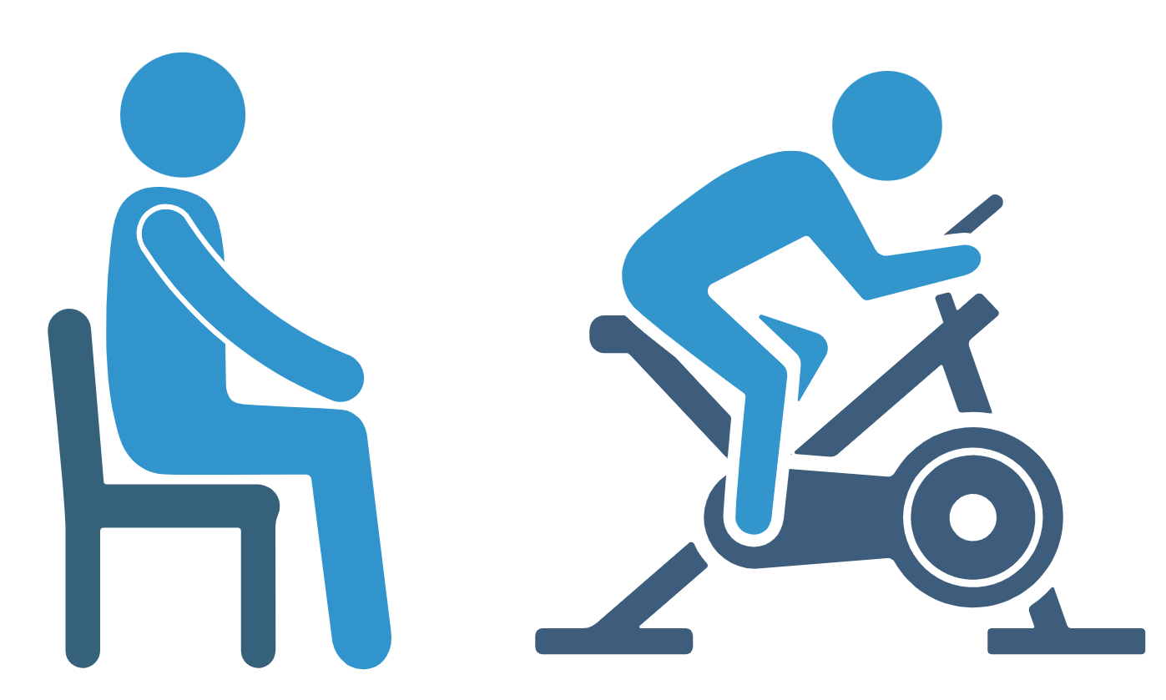
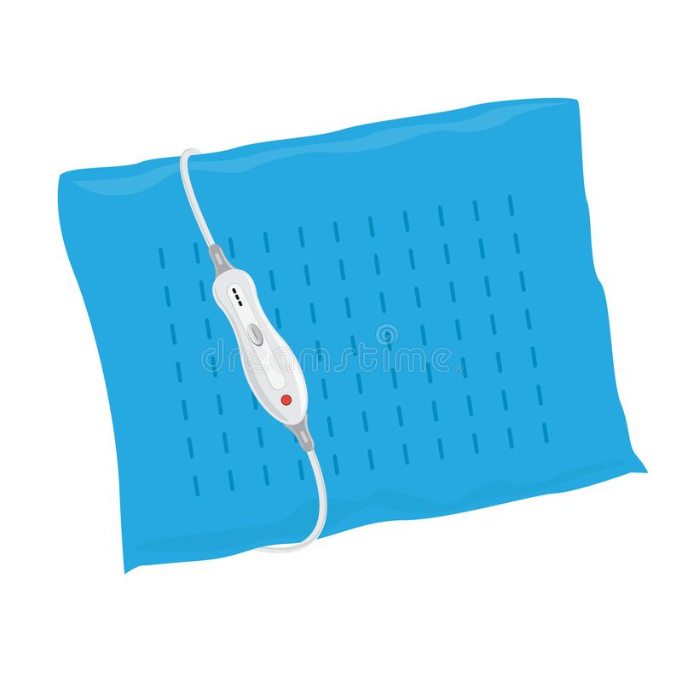
- Maximal exercise capacity

Interventions:
- Heat pad therapy on legs (at home 5 days/week, at Texas Tech 1 day/week)
- HIIT (High Intensity Interval Training; cycling 3 days/week)

Compensation:
- Earn up to $1180 for the maximum of ~81.5 lab hours

Benefits of participation include:
Body composition and bone density scans ∙ Physical function assessment

Interested in participating in the HEAT Study?
For more information, please scan the QR code above or call Hilliard, Terrell at
806-834-5585


This research project has been approved by the TTU Institutional Review Board.
This study is directed by Drs. Hui-Ying Luk and Danielle Levitt in the Department of Kinesiology & Sport Management at Texas Tech University

